## NOTEBOOK 3

NETAJI SUBHASH INSTITUTE OF TECHNOLOGY, NEW DELHI

Sarthak Tandon, Mansi Breja

# **ABSTRACT**

____________________________________________________________________________

The objective of this notebook was to put to application the basics of the design of digital systems on Arduino (open-hardware) that we learnt in the previous notebook numbered 1.

We learned to connect the Arduino with external input and output peripherals, obtained a higher-level system, learned about sensors, buzzers, LEDs, transistors and the like.

We learned to assemble the basic constituents into a real time application which in this case was a DOMOTIC SYSTEM.

# **TOOLS USED**

The programs were supposed to be understood and tested by us. The best way to understand a piece of code is to rewrite it and test it on our own. TINKERCAD simulator was used by our team to test and run the programs. TINKERCAD is an online simulator powered by AUTODESK. Tinkercad is an easy, browser-based 3D design and modelling tool for all. Tinkercad allows users to imagine anything and then design it in minutes.

# **AIR CONDITIONING SYSTEM**

## Circuitry

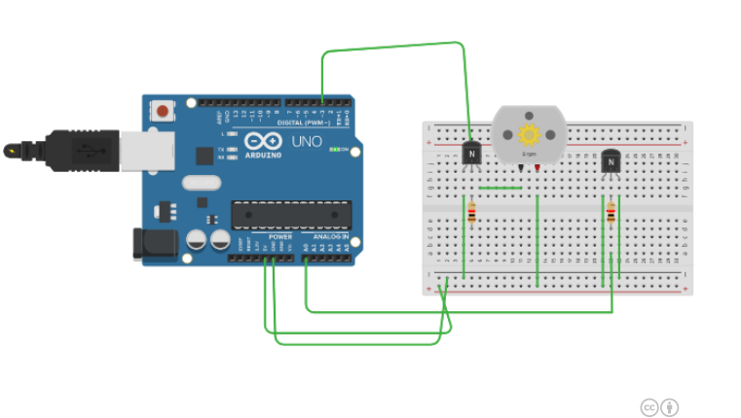

**This circuit uses the following components on Tinkercad:**

-Arduino

-Breadboard

-Motor

-Transistors

-Resistances

**The code that simulates this is:**

//DOMOTIC AIR CONDITIONING SYSTEM CODE BEGINS

float a;

int del=1000;

int temperature;

int b=3975;

int resistance;

int motor=3;

int c;

int velocity;

void setup()

{

Serial.begin(9600);

pinMode(motor, OUTPUT);

}

void loop()

{

a=analogRead(A0);

temperature = (5.0/1024.0*a*1000.0 + 45);

delay(del);

if(temperature>20 && temperature<=25)

{

c = 2;

velocity = map(c, 0, 5, 0, 255 );

analogWrite(motor, velocity);

}

if(temperature > 25 && temperature<= 30)

{

c = 3;

velocity = map(c, 0, 5, 0, 255);

analogWrite(motor, velocity);

}

if(temperature > 30)

{

c = 5;

velocity = map(c, 0, 5, 0, 255);

analogWrite(motor, velocity);

}

}

//CODE ENDS

**The screenshots from Tinker cad for the same are:**

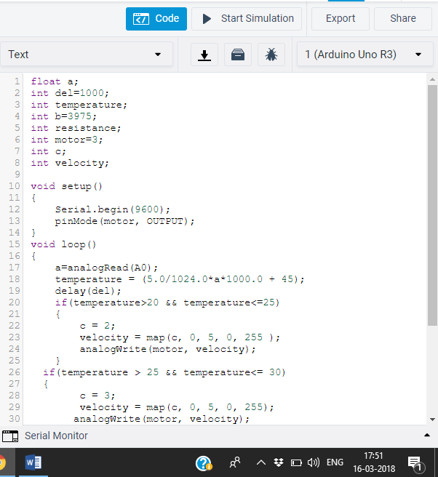

**SEE IT WORK**

<https://drive.google.com/file/d/1HQRRhiwCLlo-IdSENrXg1AYZfySYSCfl/view>

The Google Drive Link above contains videos of the simulations we prepared for the above exercise. We hope it helps in giving you a better view into the implementation of our AC System.

**TIME DEVOTED BY EACH GROUP MEMBER**

**Sarthak Tandon:** 50 minutes

**Mansi Breja:** 30 minutes

**CONCLUSION**

The assigned task of designing a Automated Air Conditioning System for a Domotic House gave us an opportunity to go beyond our way and increase our familiarisation with the in depth functionality of Arduino circuitry using simulators like Tinkercad. The team developed a deep understanding of making circuits using Arduino components and controlling them.

The document provided to us was very informative, and it guided us wonderfully throughout the project completion. Our professor, Dr. Pinaki Chakraborty helped us in all possible ways and guided us throughout.

Our basic knowledge of the programming languages of C/C++ also helped us in accomplishing this task and in due course, we only learned both electronics and programming better.